The two approaches of using pyplot
Given below are the two approaches (or styles) of using pyplot.
- The object-oriented style
Explicitly create figures and axes, and call methods on them.
- Using pyplot style
Directly Use pyplot functions for plotting, relying on pyplot’s ability to automatically create and manage the figures and axes.
Since both the approaches are supported by the same sub-module pyplot, these two approaches often lead to confusion. It is, therefore, necessary to clearly distinguish between the two styles.
We present python code using both the approaches for producing the following plot.
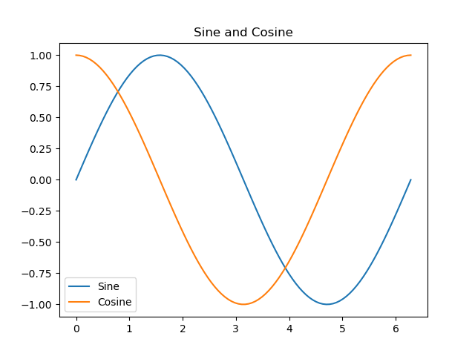
The pyplot style
x = np.linspace(0, 2*np.pi,100)
plt.plot(x, np.sin(x), label='Sine')
plt.plot(x, np.cos(x), label='Cosine')
plt.title("Sine and Cosine")
plt.legend()
plt.show()
This approach is also called the state-based approach, as it depends on the fact that pyplot preserves states of the plots across function calls. Thus, a series of plotting commands typically plots on the same figure, until a figure is displayed using the command
plt.show()
Once, a figure is displayed using above command, figure cannot be modified by a subsequent plotting command.
The object-oriented style
x = np.linspace(0, 2*np.pi,100)
fig, ax = plt.subplots()
ax.plot(x, np.sin(x), label='Sine')
ax.plot(x, np.cos(x), label='Cosine')
ax.set_title("Sine and Cosine")
ax.legend()
plt.show()

It is suggested that new learners of matplotlib should prefer object-oriented approach over the state-based approach. However, for interactive environments such as Jupyter notebook, the state-based approach may be more convenient to use.
The Plotting functions
plot function
plot(x, y, fmt)
The plot function returns the list of Line2D objects.
Arbitrary number of triplets can be supplied to plot function.
plot(x1, y1, fmt1, x2, y2, fmt2, …, xk, yk, fmtk)
if the data to be plotted is in a data structure such as dict or DataFrame, where individual variables can be accessed using strings, we can specify the data using data argument.

Format String
A format string consists of a part for color, marker and line:
fmt = '[marker][line][color]'
Each of them is optional. If not provided, the value from the style cycle is used. Exception: If line is given, but no marker, the data will be a line without markers.
Other permutations for the format string such as [color][marker][line] are also supported.

Markers
character | description
'.' | point marker
',' | pixel marker
'o' | circle marker
'v' | triangle_down marker
'^' | triangle_up marker
'<' | triangle_left marker
'>' | triangle_right marker
'1' | tri_down marker
'2' | tri_up marker
'3' | tri_left marker
'4' | tri_right marker
's' | square marker
'p' | pentagon marker
'*' | star marker
'h' | hexagon1 marker
'H' | hexagon2 marker
'+' | plus marker
'x' | x marker
'D' | diamond marker
'd' | thin_diamond marker
'|' | vline marker
'_' | hline marker

Line Styles
character | description
'-' | solid line style
'--' | dashed line style
'-.' | dash-dot line style
':' | dotted line style

Example format strings
'b' # blue markers with default shape
'or' # red circles
'-g' # green solid line
'--' # dashed line with default color
'^k:' # black triangle_up markers connected by a dotted line
Colors
The supported color abbreviations are the single letter codes
character | color
'b' | blue
'g' | green
'r' | red
'c' | cyan
'm' | magenta
'y' | yellow
'k' | black
'w' | white

If the color is the only part of the format string, you can additionally use any matplotlib.colors spec, e.g. full names ('green') or hex strings ('#008000').

Specifying Line properties
plt.plot(x, y, fmt, **kwargs)
Here kwargs specifies the line properties in matplotlib.lines.Lines2D.
Line properties can also be set using setter methods of Line2D object.
There are several global settings known as “rc parameters”. These values can also be supplied as arguments to the plot function.
Some more Pyplot Commands

Specify X axis label: plt.xlabel
Specify Y axis label plt.ylabel
Specify graph Title plt.title
Adding Legend plt.legend
Specify X limits Plt.xlim
Specify Y limits Plt.ylim
Specify ticks plt.xticks, plt.yticks
Specify both limits plt.axis
Hide axis: plt.axis(‘off’)
Adding axes plt.axes
Apply stylesheet plt.style.use
Add annotation plt.annotate
Create subplots plt.subplot
Pseudo color plot: plt.pcolor
Show color bar: plt.colorbar()
Save Figure: plt.savefig
Improved spacing between plots: plt.tight_layout

Using mathematical expressions in text
matplotlib accepts TeX equation expressions in any text expression. For example,
plt.title(r'$\sigma_i=15$')

Matplotlib styles
Matplotlib provides styles, which are similar to CSS for webpages. A style comprises of various customizations such as font, font size, grids, colors, line properties, and so on. The styles are created using style pages (files with .mplstyle extension).
In order to use styles, first we need to import style module.
from matplotlib import style
Then a style can be applied using a command like
style.use(‘ggplot’)
This command applies the style as specified in ggplot.mplstyle file.
Matplotlib provides several ready to use styles. Available styles can be seen using
style.available
It is also possible to create our own custom styles.
The style sheets have cumulative effect. Thus multiple styles can be used to obtain the cumulative effect.

